**Test Case 1: Listing All Wi-Fi Spots**

* **Given** the user navigates to the Wi-Fi spots listing page.
* **When** the page loads.
* **Then** the app should display a list of all available Wi-Fi spots with basic details (name, location type, etc.).

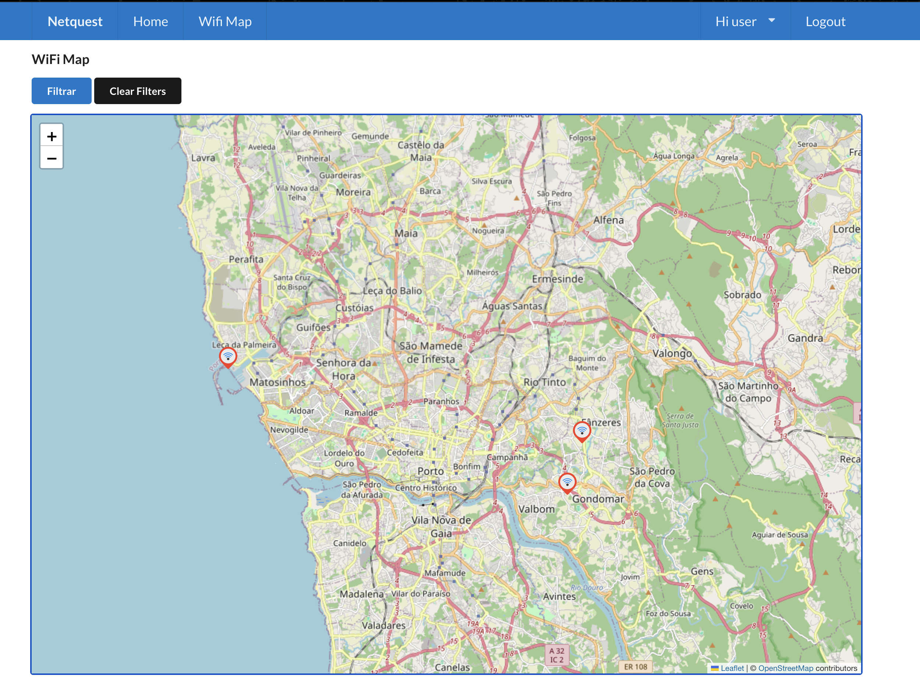

**Test Case 2: Filtering Exact by Name**

* **Given** the user is on the Wi-Fi spots listing page.
* **When** the user enters a name and selects the "Exact" checkbox.
* **Then** the app should display only the Wi-Fi spots that match the exact name entered.

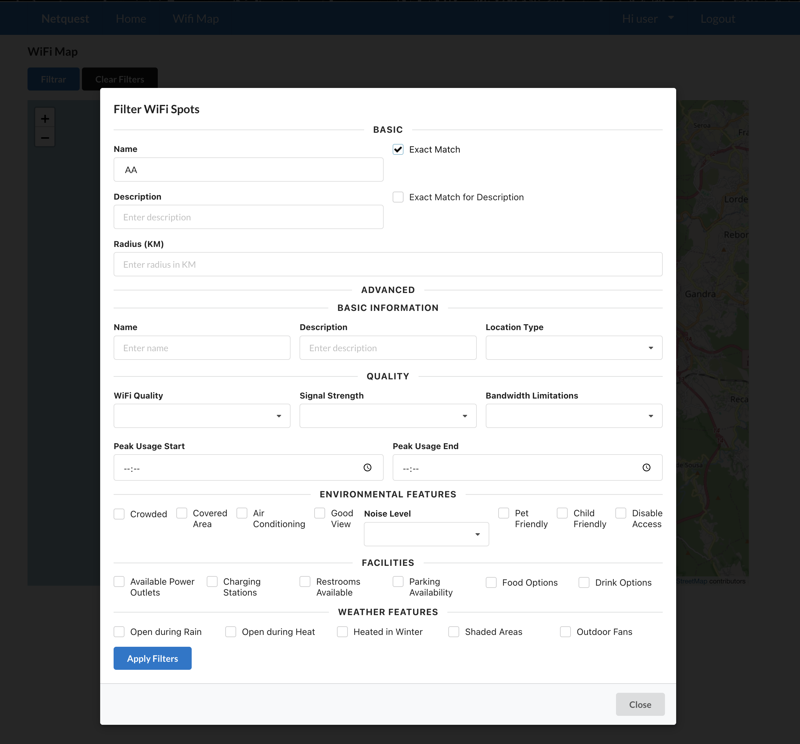

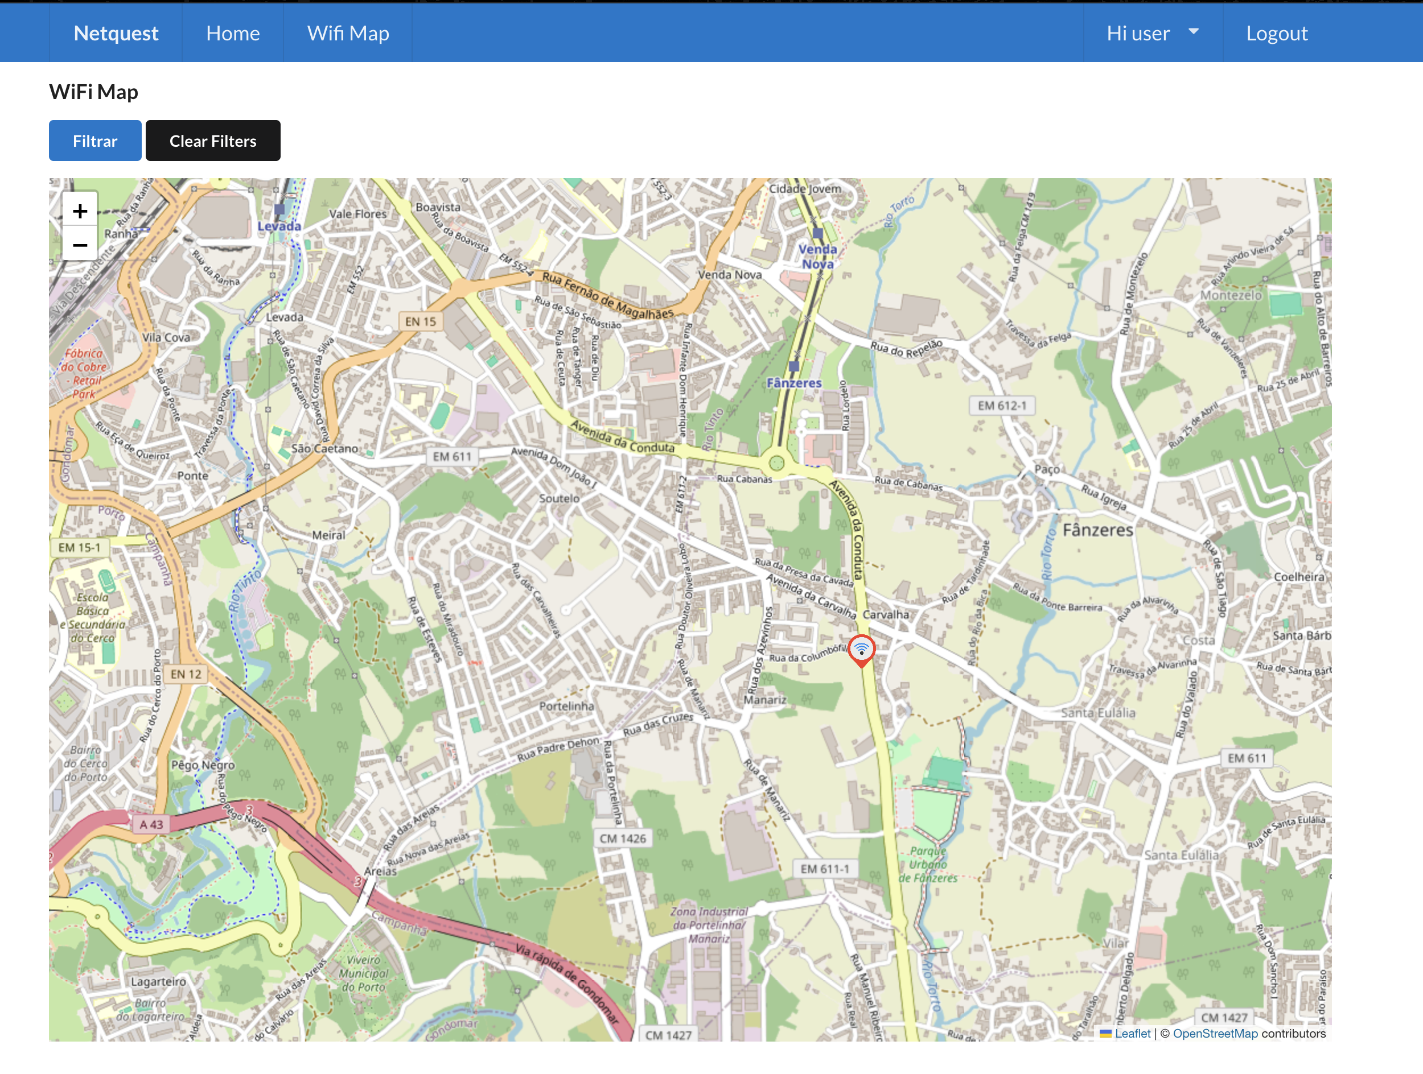

**Test Case 3: Filtering Exact by Description**

* **Given** the user is on the Wi-Fi spots listing page.
* **When** the user enters a description and selects the "Exact" checkbox.
* **Then** the app should display only the Wi-Fi spots that match the exact description entered.

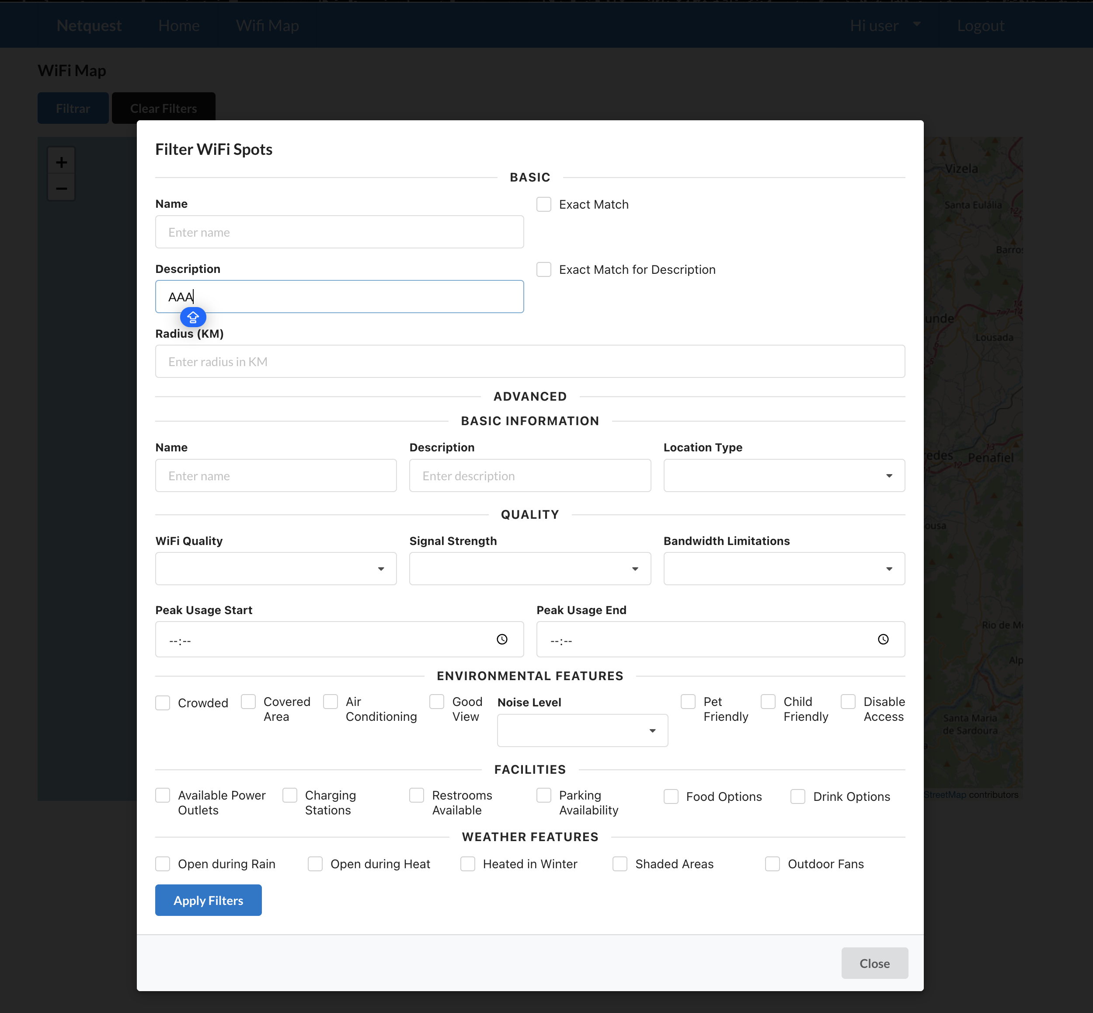

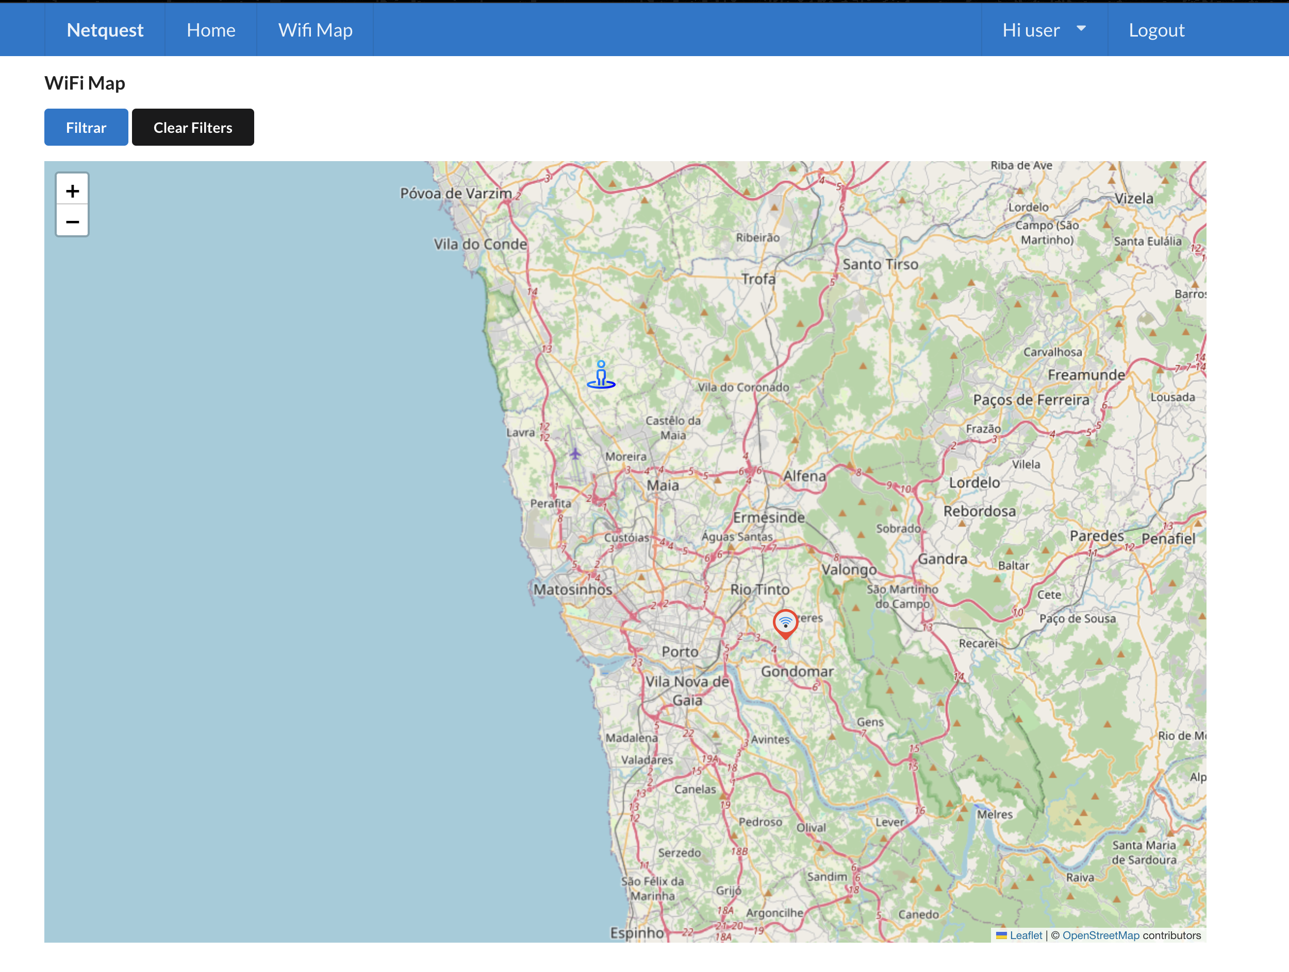

**Test Case 4: Advanced Filtering by Location Type**

* **Given** the user is on the Wi-Fi spots listing page.
* **When** the user selects a location type (e.g., Cafe) from the dropdown list.
* **Then** the app should display only the Wi-Fi spots that match the selected location type.

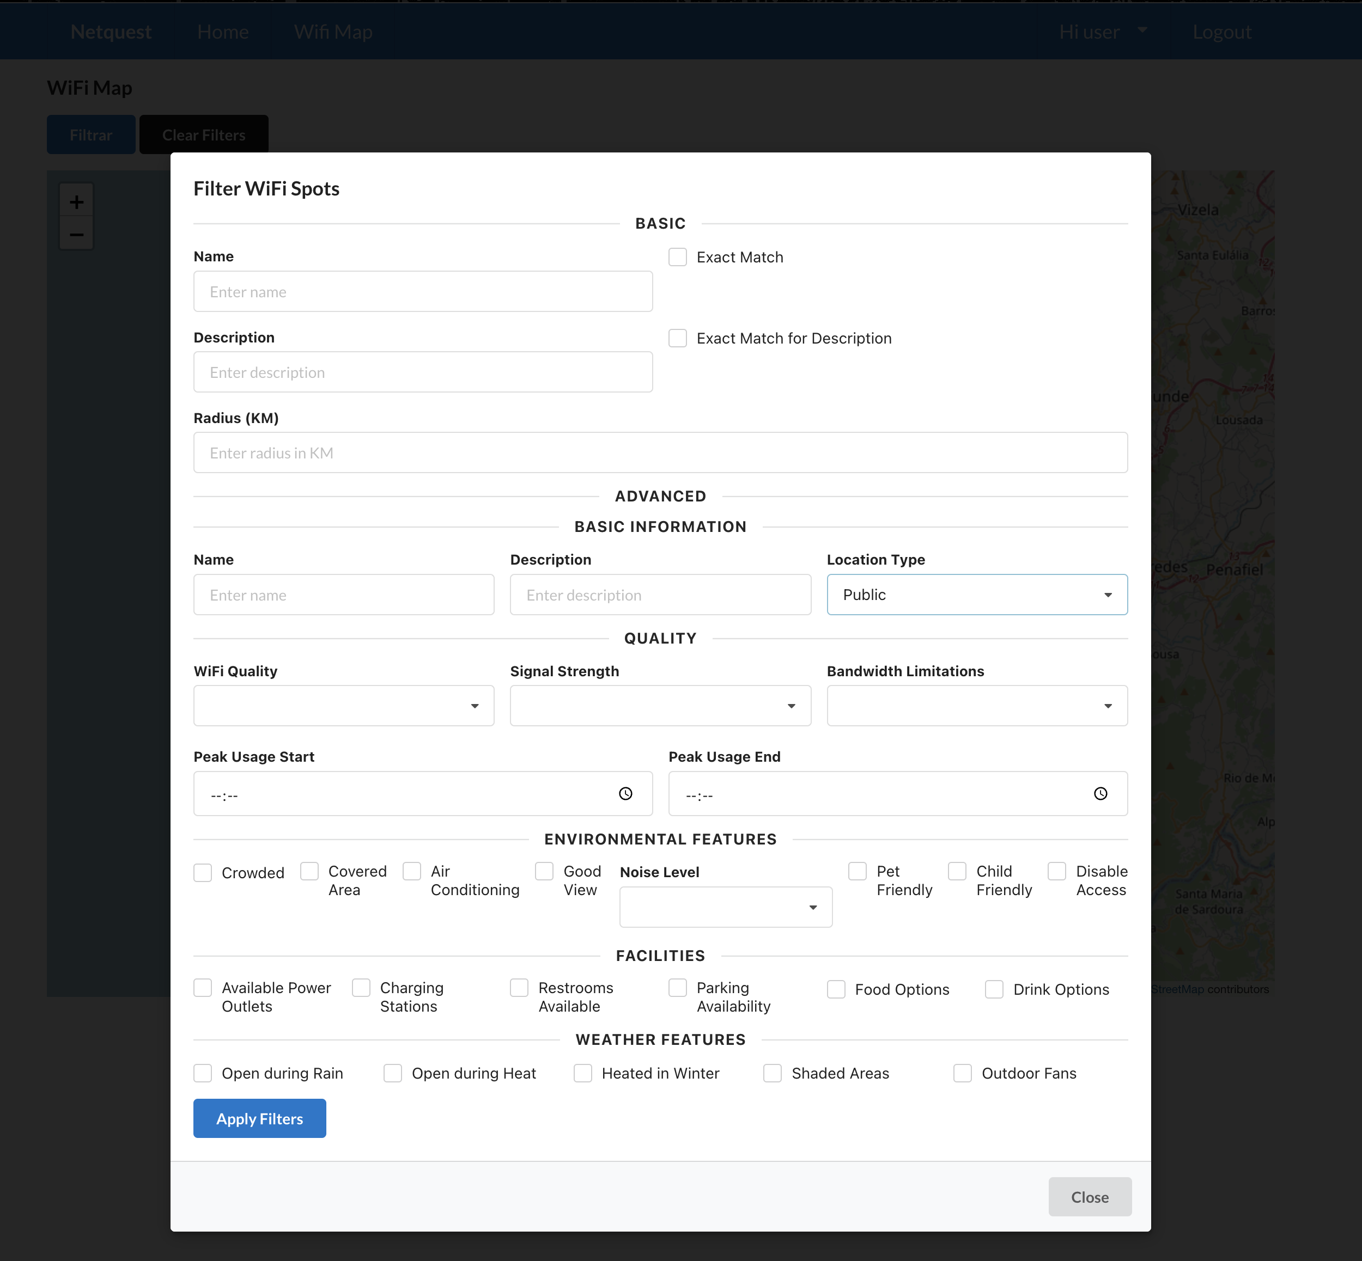

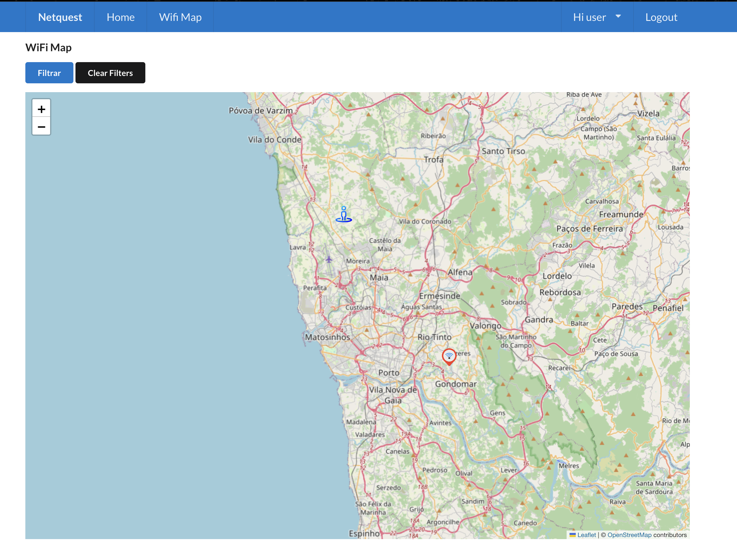

**Test Case 5: Applying Multiple Filters**

* **Given** the user has selected multiple filters (e.g., High Wi-Fi quality, Cafe location type, and within a 5 KM radius).
* **When** the user applies the filters.
* **Then** the app should display only the Wi-Fi spots that meet all selected criteria.

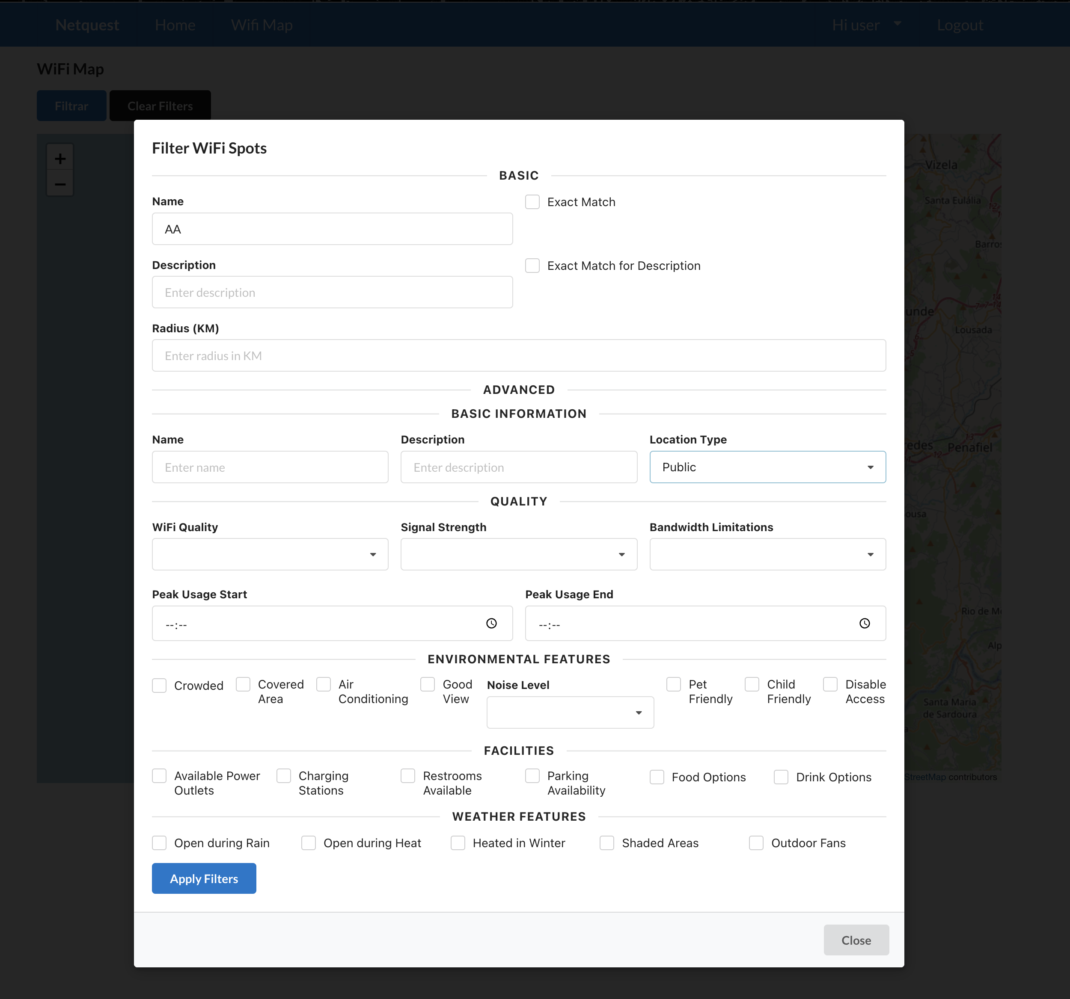



**Test Case 6: Clearing All Filters**

* **Given** the user has applied several filters on the Wi-Fi spots listing page.
* **When** the user clicks the "Clear Filters" button.
* **Then** the app should refresh the list of Wi-Fi spots to show all available options without any filters applied.

